PRESS RELEASE
COMMUNICATIONS AND MEDIA TEAM OF THE 43RD ASEAN SUMMIT 2023
No. 93/SP/TKM-ASEAN2023/ENG/9/2023

Indonesia, the 7th Asian Country Visited by US VP Kamala Harris
Jakarta, 6 September 2023 – The Vice President (VP) of the United States of America (US) Kamala Harris began her visit to Indonesia on Tuesday (5 September 2023). Harris, The first female VP of the superpower nation, arrived in Jakarta to attend the Association of Southeast Asian Nations (ASEAN) Summit with strategic partners such as Japan, South Korea, China, Australia, and the US.
This is the seventh visit to the Asian continent and the fifth time to Southeast Asia for the woman who was born on 20 October 1964. Her visit to the region this time is in her capacity as the VP representing President Joe Biden.
Kamala Harris arrived at the Soekarno Hatta Airport on Tuesday (5 September 2023), at approximately 10:00 PM local time. The Indonesian Minister of Health Budi Gunadi Sadikin welcomed her arrival.
Prior to Jakarta, Harris had conducted state visits to Singapore, Vietnam, Thailand, and the Philippines. She had also visited Japan and South Korea.
The ASEAN leaders initially hoped that the 43rd ASEAN Summit with dialogue partners would be attended by President Biden, as the 46th President of the United States (POTUS) did at the ASEAN Summit in Phnom Penh, Cambodia (13 November 2022). At that time, the POTUS flew directly to Nusa Dua, Bali, after the meeting in Cambodia to attend the Group of 20 (G20) Development Cooperation Forum, which was also a meeting of heads of state and government.
However, the White House had announced from the outset that the POTUS would directly go to New Delhi, India, to attend the G20 Summit on 9 – 10 September 2023.
According to John Kirby, the White House National Security Spokesperson, Washington continues to view the Indo-Pacific region and ASEAN as strategic partners and integral parts of the VP’s visit to Jakarta.
VP Harris, as Kirby noted, is highly focused on maintaining Washington's harmonious relations with all countries in the Indo-Pacific region. This can be seen in the number of countries in Asia the former California state senator has visited compared to visits to other continents.
The White House stated that VP Harris departed Washington on Monday (4 September 2023) local time and arrived at Soekarno-Hatta Airport at around 10:00 PM local time on Tuesday (5 September 2023). She will be in Jakarta for two days to participate in the ASEAN Summit and meetings with strategic partner countries.
She is scheduled to hold bilateral meetings with several heads of state and government leaders attending the 43rd ASEAN Summit in 2023 at the Jakarta Convention Center (5 – 7 September 2023). Upon Harris' return to the US, it will be President Biden's turn to fly to New Delhi. (Anton Setiawan/Wisnu Wardoyo)
***
For more information, please contact:
Director General of Public Information and Communications of the Ministry of Communications and Informatics – Usman Kansong (0816785320).
Get more information at http://asean2023.id, https://infopublik.id/kategori/asean-2023, and https://indonesia.go.id/kategori/ragam-asean-2023

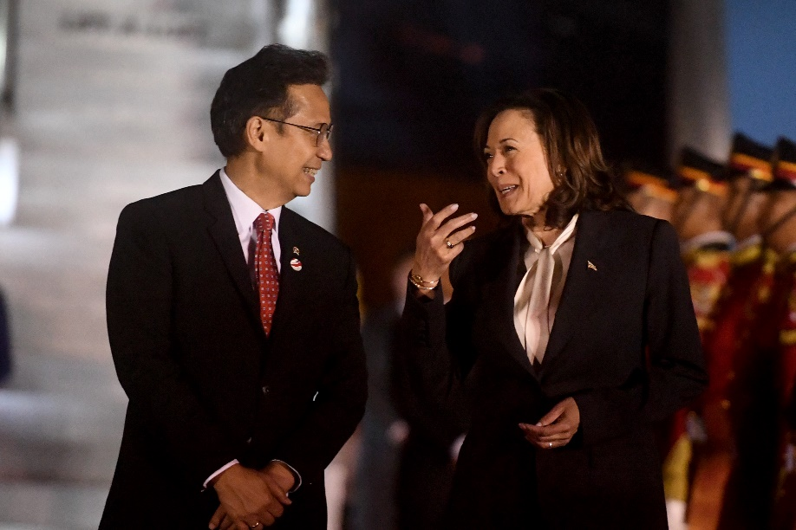
The Vice President of the United States of America Kamala Harris (right) conversing with Indonesian Minister of Health Budi Gunadi Sadikin (left) who welcomed her arrival at the Soekarno-Hatta Airport, Tangerang, Banten, Tuesday (5 September 2023). Media Center KTT ASEAN 2023/Muhammad Adimaja/pras.

